Condition Variables
# Source: AI Source: Provided by: [Data Path: Persons Table -> ID Column: 1, Name_En Column: Motasem Essam] -> From: [ChatGPT] on [1/21/2026]
Condition Variables are a synchronization mechanism used in Real-Time Systems (RTS) to allow tasks to wait for certain conditions to become true before continuing execution. They are often used together with mutexes or monitors.

Definition
# Source: AI Source: Provided by: [Data Path: Persons Table -> ID Column: 1, Name_En Column: Motasem Essam] -> From: [ChatGPT] on [1/21/2026]
A condition variable is an object that allows tasks to:
- Wait for a specific condition or event.
- Signal other tasks when that condition has occurred.
It does not control mutual exclusion by itself; it is usually paired with a mutex or monitor to safely access shared data.

Key Features
# Source: AI Source: Provided by: [Data Path: Persons Table -> ID Column: 1, Name_En Column: Motasem Essam] -> From: [ChatGPT] on [1/21/2026]
- Wait / Sleep:
  - wait() → the task releases the associated mutex and waits until signaled.
- Signal / Notify:
  - signal() → wakes up one waiting task.
  - broadcast() → wakes up all waiting tasks.
- Requires a Mutex: Condition variables cannot be used alone; they must be associated with a mutex to avoid race conditions.
- Used for Coordination: Allows tasks to sleep efficiently instead of busy-waiting.

Example
# Source: AI Source: Provided by: [Data Path: Persons Table -> ID Column: 1, Name_En Column: Motasem Essam] -> From: [ChatGPT] on [1/21/2026]
Consider the Producer-Consumer Problem:
- Shared buffer protected by a mutex.
- Condition variables: notFull and notEmpty.
Producer Task:
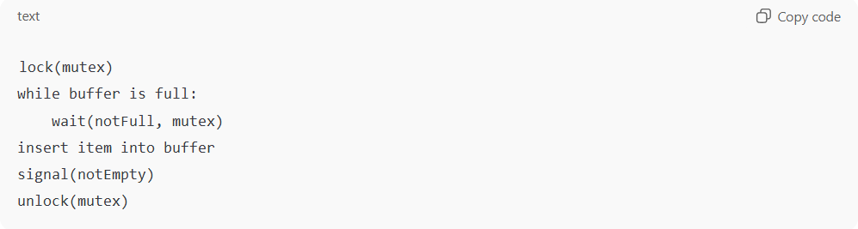
lock(mutex)
while buffer is full:
wait(notFull, mutex)
insert item into buffer
signal(notEmpty)
unlock(mutex)
Consumer Task:
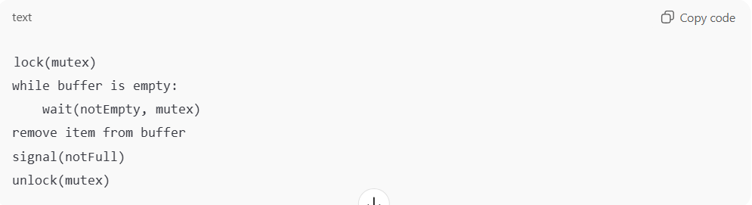
lock(mutex)
while buffer is empty:
wait(notEmpty, mutex)
remove item from buffer
signal(notFull)
unlock(mutex)
- Producers wait if the buffer is full; consumers wait if empty.
- Signals notify waiting tasks when they can proceed.

Advantages
# Source: AI Source: Provided by: [Data Path: Persons Table -> ID Column: 1, Name_En Column: Motasem Essam] -> From: [ChatGPT] on [1/21/2026]
- Efficiently blocks tasks without consuming CPU.
- Enables fine-grained coordination between tasks.
- Works seamlessly with mutexes and monitors.

Disadvantages
# Source: AI Source: Provided by: [Data Path: Persons Table -> ID Column: 1, Name_En Column: Motasem Essam] -> From: [ChatGPT] on [1/21/2026]
- Must be used carefully with mutexes to avoid deadlocks.
- Misuse can lead to missed signals or spurious wake-ups.

Why Condition Variables Matter for Software Engineers
# Source: AI Source: Provided by: [Data Path: Persons Table -> ID Column: 1, Name_En Column: Motasem Essam] -> From: [ChatGPT] on [1/21/2026]
- Essential for task coordination in real-time and concurrent systems.
- Improves efficiency by preventing busy-waiting.
- Commonly used in embedded systems, multithreading, robotics, and RTOS development.

